San Francisco GYROTONIC®
26 7th Street, 4th Floor San Francisco, CA 94103 (415) 863-3719
www.sfgyrotonic.com

WELCOME TO SAN FRANCISCO GYROTONIC®

We are located at 26 7th Street in the heart of downtown San Francisco. This is a traditionally diverse, urban business area that is centrally located and easily accessed by public transportation. Home of Twitter, Uber, SF Opera, SF Ballet, the Civic Center Farmers’ Market, and the newly renovated Museum of Modern Art. This is an area that is vibrant and colorful.

As with any large metropolitan urban area, be aware of your surroundings as well as your valuables.

HOW TO GET TO US:

By MUNI (above and below ground busses):
Take any of these buses to the intersection of 7th and Market Streets: 6 - 7 - 9 - 19 - 21 - F (the 5 bus is one block up on McAlister and 7th) Take any of these underground lines to the Civic Center Station:
J, K, T, L, M, or N
Obtain a transfer from the driver or use Muni Mobile app to pay for your ride.
Fare: $2.50 if paying electronically, $3.00 if paying directly to the driver in cash

By BART (rapid transit):

You will need to purchase a Clipper Card to ride BART. Learn more at https://www.clippercard.com/ClipperWeb/ and purchase online or at the station. Clipper Cards are also good for MUNI rides.
We are located at Civic Center BART Station.
BART goes directly from San Francisco Airport and Oakland Airport to Civic Center Station. From the Oakland airport however, you need to transfer to a San Francisco bound train at Oakland/Coliseum station.
Fare: Depends on destination. Example:
Anywhere within the city proper- $2.15
SF Airport to Civic Center- $10
Oakland Airport to Civic Center- $11.40
Learn more about schedule and fares at https://www.bart.gov/

WHERE TO PARK

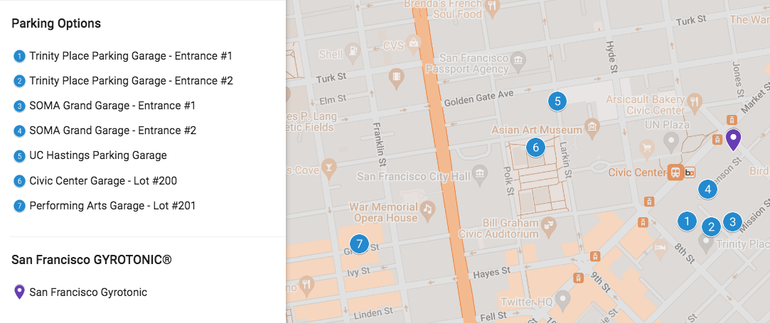
Name of Garage | Address/Entrance | Hourly and Daily Rates | Distance from SFG
Trinity Place Parking Garage  (Whole Foods Garage) | Two entrances:  -1: 33 8th St.  -2: 1188 Mission St. | 20 mins = $5  Up to 12 hours = $25  Early Bird (in before 9am) = $20 | 1 minute walk to SFG
SOMA Grand Garage | Two entrances:  -1: 1160 Mission St.  -2: Stevenson St. Alleyway | Early Bird (in before 9am) = $20  Maximum = $40 | 1 minute walk to SFG
UC Hastings Parking Garage | 367 Larkin St. | Under 1 hour = $3  4.5 hours – Maximum = $27  Early Bird (in by 9am exit by 7pm, Mon-Fri) = $18  Sunday Rate = $9 | 7 minute walk to SFG
Civic Center Garage – Lot #200 | 355 McAllister St. | Daily (12 hours) = $29  Daily Maximum  Early Bird (in by 8:30am exit by 7pm, Mon-Fri) = $20 | 7 minute walk to SFG
Performing Arts Garage – Lot #201 | 360 Grove St. | 12 hour Maximum = $22  Early Bird (in before 9am exit by 7pm) = $14 | 15 minute walk to SFG

We also recommend the SpotAngels App, built to find both street parking and garages as well as gas nearby with reviews and easy to find pricing.

WEATHER

San Francisco mornings can be chilly. Bring clothing that can be layered and removed as the day warms. Bring walking shoes. San Francisco has seven hills! Please bring or wear socks to our studio.

If you have any questions, please do not hesitate to contact us at (415) 863- 3719 or email us at courses@sfgyrotonic.com

